Assignment – 8
Formatting Query Output
- Assume each salesperson has a 12% commission. Write a query on the Orders table that will produce the order number, the salesperson number, and the amount of the salesperson’s commission for that order.
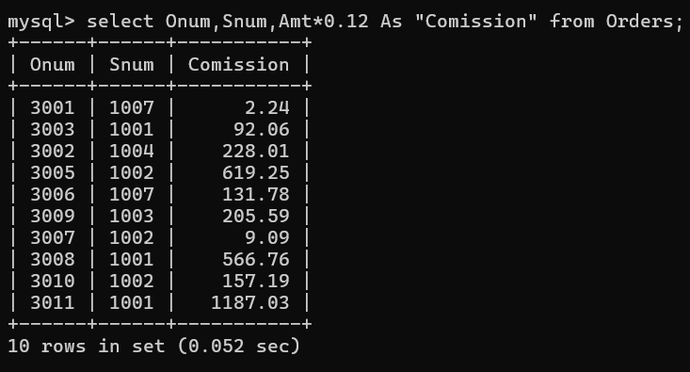
- Write a query on the Customers table that will find the highest rating in each city. Format the output so it appears like this:
For the city (city), the highest rating is : (rating).
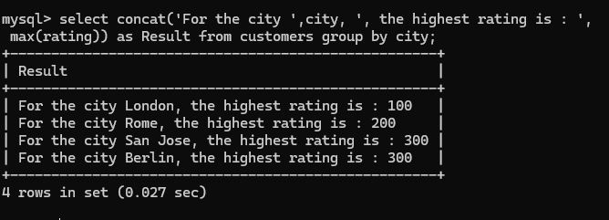

- Write a query that lists customers in descending order of rating. The output should display the rating field first, followed by the customer’s name and number.
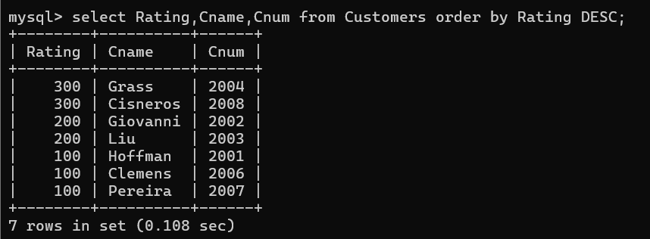
- Write a query that totals the orders for each day and places the results in descending order.
